

**Tribhuvan University**

**Institution of Science and Technology**

**A Final Year Report On**

**INTERNSHIP**

**Under the Supervision of**

**Er. Dhiraj Kumar Jha**

**Lecturer**

**Orchid International College**

**Submitted To:**

**DEPARTMENT OF COMPUTER SCIENCE AND INFORMATION TECHNOLOGY**

**ORCHID INTERNATIONAL COLLEGE**

**In partial fulfillment for the Bachelor’s Degree in Computer Science and Information Technology**

**Submitted By:**

**Ankit Shrestha (23863/076)**

**June 2024**

# **COMPLETION LETTER**

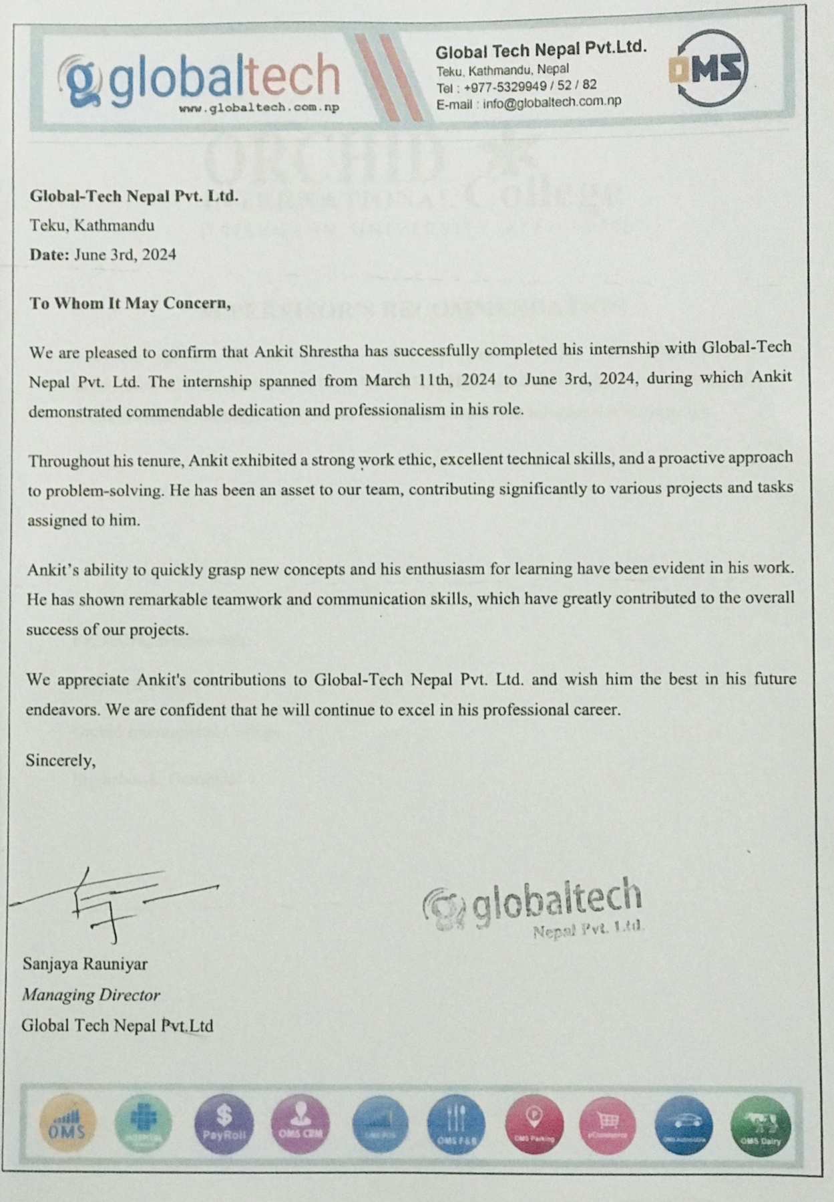



# **SUPERVISOR’S RECOMMENDATION**

I hereby approve the report made under my supervision by Ankit Shrestha (TU  
Exam Roll No. 23863/076) entitled "**INTERNSHIP**" will be evaluated as part of the requirements for the degree of B.Sc. in Computer Science and Information Technology.

…………………………

**Er. Dhiraj Kumar Jha**

Full Time Faculty

Orchid International College

Bijyachowk, Gaushala



# **CERTIFICATE OF APPROVAL**

This certifies that the "Internship" report, completed by Ankit Shrestha (TU Exam Roll No. 23863/076), partially fulfills the requirements for the degree of B.Sc. in Computer Science and Information Technology. We affirm its suitability as a project for the desired degree based on its scope and quality.

|  |  |
| --- | --- |
| ……………………..  **Er. Dhiraj Kumar Jha**  Supervisor,  Orchid International College  Bijyachowk, Gaushala | ……………………  **External Examiner**  Central Department of Computer Science and IT, Tribhuvan University  Kritipur, Nepal |

# **ACKNOWLEDGEMENT**

I extend my heartfelt gratitude to all who have contributed to the completion of this internship report. Firstly, I would like to express my deepest appreciation to Er. Dhiraj Kumar Jha for their invaluable guidance, support, and encouragement throughout this internship journey. Their expertise and mentorship have been instrumental in shaping my learning experience and the successful completion of this report.

I also extend my sincere thanks to Trubhuvan University and Orchid International College for providing me with the opportunity to undertake this internship and gain practical insights into the field of ASP.NET (MVC). I am grateful for the knowledge and skills acquired during my time at the university and college, which have significantly enriched my understanding of software development.

Lastly, I express my gratitude to Global-Tech Nepal Pvt. Ltd. for providing a platform for experiential learning and facilitating this internship opportunity. This report is a culmination of the collective efforts and support from all those mentioned above, and I am truly grateful for their contributions.

# **ABSTRACT**

This internship report details the experience gained at Global-Tech Nepal Pvt. Ltd., where the focus was on applying the ASP.NET MVC framework to develop enterprise web applications. The background emphasizes the company's leadership in software development and cloud computing, highlighting their commitment to innovation and client-centric solutions. The problem addressed is the need for practical, hands-on experience in web development, database management, and software engineering within a professional environment. Objectives included enhancing skills in frontend development (HTML, CSS, JavaScript, Bootstrap5), backend programming with C# ASP.NET MVC, and database management using SQL Server Management Studio (SSMS), along with understanding software engineering practices like user authentication, authorization, and RESTful API development. Methodology involved leveraging the Model-View-Controller (MVC) architecture to ensure separation of concerns and streamline development, evidenced through projects such as the Company Registration System, Payment and Loan Management System, and Web API development. The conclusion underscores the significance of practical learning in preparing for a career in software development.

***Keywords:******ASP.NET MVC, web development, database management, frontend development, backend development, SSMS, RESTful API***

**TABLE OF CONTENT**

**COMPLETION LETTER** i

**SUPERVISOR’S RECOMMENDATION** ii

**CERTIFICATE OF APPROVAL** iii

**ACKNOWLEDGEMENT** iv

**ABSTRACT** v

**LIST OF ABBREVIATIONS** viii

**LIST OF TABLES** ix

**LIST OF FIGURES** x

**CHAPTER 1-INTRODUCTION** 1

**1.1 Introduction** 1

**1.2 Problem Statement** 1

**1.3 Objectives** 2

**1.4** **Scope and Limitation** 2

**1.5 Report Organization** 3

**CHAPTER 2-INTRODUCTION TO ORGANIZATION AND LITERATURE REVIEW** 4

**2.1 Organization Details** 4

**2.2 Organization Hierarchy** 5

**2.3 Work Domain of Organization** 6

**2.4 Description of Intern Department/Unit** 7

**2.5 Literature Review / Related Study** 8

**CHAPTER 3-INTERNSHIP ACTIVITIES** 10

**3.1 Roles and Responsibility** 10

**3.2 Weekly Log** 10

**3.3 Description of the Projects Involved During Internship** 13

**3.3.1 System Analysis** 13

**3.3.2 System Design** 18

**3.3.3 Tasks Completed** 23

**3.4 Tasks / Activities Performed** 25

**CHAPTER 4-CONCLUSION AND LEARNING OUTCOME** 28

**4.1 Conclusion** 28

**4.2 Learning Outcome** 28

**REFERENCES** 29

**APPENDIX** 30

# 

# **LIST OF ABBREVIATIONS**

Some of the abbreviations used in are shown below:

|  |  |
| --- | --- |
| ASP.NET MVC | Active Server Pages .NET Model-View-Controller |
| HTML | Hypertext Markup Language |
| CSS | Cascading Style Sheets |
| SSMS | SQL Server Management Studio |
| RESTful API | Representational State Transfer Application Programming Interface |
| C# | C Sharp (programming language) |
| SQL | Structured Query Language |
| ADO.NET | ActiveX Data Objects .NET |
| DTO | Data Transfer Object |
| API | Application Programming Interface |
| CRUD | Create, Read, Update, Delete |
| OMS | Organization Management Software |
| ERP | Enterprise Resource Planning |
| CMS | Content Management System |
| IaaS | Infrastructure as a Service |
| PaaS | Platform as a Service |
| SaaS | Software as a Service |

# **LIST OF TABLES**

**Table 2.1: Contact Details of Organization 4**

**Table 3.1: Details of Weekly Log 10**

**Table 3. 2: Use Case for Registration 14**

**Table 3. 3: Use Case for Login 15**

**Table 3. 4: Use Case for Manage Company Information 15**

**Table 3. 5: Use Case for User Registration 16**

**Table 3. 6: Use Case for User Login 17**

**Table 3. 7: Use Case for Manage Loan Categories 17**

**Table 3. 8: Use Case for Manage Overdraft Table 17**

**Table 3. 9: Use Case for Manage Working Capital Table 18**

**Table 3. 10: Internship Duration 25**

**Table 3. 11: Tools Used 27**

# **LIST OF FIGURES**

**Figure 2. 1: Organization Logo 5**

**Figure 2. 2: Organization Chart 5**

**Figure 3. 1: Use Case Diagram of Company Registration System 14**

**Figure 3. 2: Use Case Diagram of Loan Management System 16**

**Figure 3. 3: MVC 19**

**Figure 3. 4: ER Diagram of Company Registration System 20**

**Figure 3. 5: ER Diagram of Loan Management System 20**

**Figure 3. 6: Class Diagram of Company Registration System 21**

**Figure 3. 7: Class Diagram of Loan Management System 21**

**Figure 3. 8: Activity Diagram of Company Registration System 22**

**Figure 3. 9: Activity Diagram of Loan Management System 22**

**Figure 3. 10: Company Registration System 23**

**Figure 3. 11: Loan Management System 24**

# **CHAPTER 1-INTRODUCTION**

## **1.1 Introduction**

The internship was conducted at Global-Tech Nepal Pvt. Ltd., a prominent technology firm in Teku, Kathmandu, from March 11th, 2024, to June 3rd, 2024. During this period, the intern worked as an ASP.NET (MVC) intern, gaining hands-on experience in web development and applying theoretical knowledge from academic studies. Global-Tech Nepal is renowned for its innovative technology solutions, focusing on high-quality software development, IT consulting, and system integration services, including cloud-based services. The company's commitment to excellence and advanced technology made it an ideal environment for learning and professional growth.

The intern was integrated into the web development team. Working with ASP.NET (MVC), the intern gained practical experience in web application development and honed skills in C#, HTML, CSS, Bootstrap 5, JavaScript, and SQL Server. The internship also facilitated the development of professional competencies such as effective communication, teamwork, and time management. Mentorship from senior developers and project managers helped the intern understand industry best practices and workflows. Overall, the internship was a transformative experience that bridged the gap between academic learning and real-world application, preparing the intern for a successful career in the technology sector.

## **1.2** **Problem Statement**

Despite Global Tech Nepal Pvt. Ltd.'s commitment to customer satisfaction and its array of quality cloud computing services, there exist challenges and opportunities for improvement within the organization. While the company boasts partnerships with leading IT companies and provides innovative cloud-based solutions, there is a need to streamline its customer-centric approach to better address client needs and preferences.

Additionally, as Nepal's first cloud-based accounting software company, there is a unique opportunity to enhance and expand its service offerings to meet the evolving demands of the market. The challenge lies in optimizing internal processes, enhancing service quality, and leveraging technological advancements to consolidate Global Tech's position as a frontrunner in the field of cloud computing and IT solutions in Nepal.

## **1.3 Objectives**

* To implement and enhance practical skills in ASP.NET (MVC) development by successfully completing assigned tasks in a professional setting.
* To implement effective software development lifecycle practices through coding, testing, and insightful code reviews.

## **Scope and Limitation**

During the internship at Global-Tech Nepal Pvt. Ltd., the intern was immersed in a dynamic environment conducive to learning various dimensions of software development. This included frontend development, where proficiency was gained in crafting visually appealing and user-friendly interfaces using HTML, CSS, and JavaScript. Additionally, the intern delved into backend development utilizing C# with the ASP.NET MVC framework, contributing to the creation of robust server-side logic and functionality. Furthermore, valuable insights were obtained into database management, particularly with SQL Server Management Studio (SSMS), involving tasks such as database design and implementation.

**Limitation:**

**Software Development Limitations:**

* Direct SQL queries in ADO.NET can hinder code maintainability and readability over time.
* Debugging and troubleshooting SQL-related issues can be more complex compared to using ORM frameworks.

**Technology Limitations:**

* Scalability can be limited with direct SQL queries, especially under heavy load or with large datasets.
* Flexibility in adapting to changing business requirements may be constrained when relying solely on SQL stored procedures.

## **1.5** **Report Organization**

**Chapter 1: Introduction**

This section outlines the report's objectives and structure, offering insight into the internship's importance. It serves as a primer, setting the context for the subsequent chapters.

**Chapter 2: Introduction to Organization**

Here, Global-Tech Nepal Pvt. Ltd. is introduced, providing background information on its mission, values, and industry positioning. Readers gain a foundational understanding of the organization hosting the internship.

**Chapter 3: Background Study and Literature Review**

Exploring ASP.NET (MVC) development and related literature, this chapter lays the groundwork for understanding the theoretical underpinnings of the internship. It offers a scholarly perspective on the field of study.

**Chapter 4: Internship Activities**

This segment delves into the intern's hands-on experiences at Global-Tech Nepal Pvt. Ltd., detailing tasks, projects, and challenges encountered. It provides a practical narrative of the intern's contributions and learning journey within the organization.

**Chapter 5: Conclusion and Learning**

Wrapping up the report, this chapter reflects on the internship experience, summarizing key insights and lessons learned. It offers valuable recommendations for both future interns and the organization, closing the narrative with a sense of accomplishment and growth.

# **CHAPTER 2-INTRODUCTION TO ORGANIZATION AND LITERATURE REVIEW**

## **2.1 Organization Details**

Global-Tech Nepal Pvt. Ltd. is a prominent IT solutions provider based in Teku, Kathmandu. The company is dedicated to forging strategic alliances with renowned IT firms and cloud service providers worldwide to enhance its service portfolio and expand its global presence. The mission of Global-Tech Nepal is to deliver top-notch cloud computing solutions that meet and exceed industry standards, with a strong emphasis on data integrity and robust disaster recovery mechanisms.

Founded by a group of seasoned professionals with over 15 years of experience in various domains, including business development, ERP solutions, software development, and system and networking solutions, Global-Tech Nepal offers comprehensive solutions in software development, system integration, network management, and cloud computing. Among its core offerings are customized Organization Management Software (OMS) and ERP solutions tailored to meet the unique needs of each client, driving their business growth and operational efficiency. The company also takes pride in being Nepal's leading provider of cloud-based accounting software solutions, operating from a secure data center with strong disaster recovery capabilities.

Table 2.1: Contact Details of Organization

|  |  |
| --- | --- |
| Location | Teku, Kathmandu |
| Organization | Global-Tech Nepal Pvt. Ltd. |
| Website | https://globaltech.com.np/ |
| Email | info@globaltech.com.np |
| Phone | 01-5329949 |



Figure 2. 1: Organization Logo

## **2.2 Organization Hierarchy**

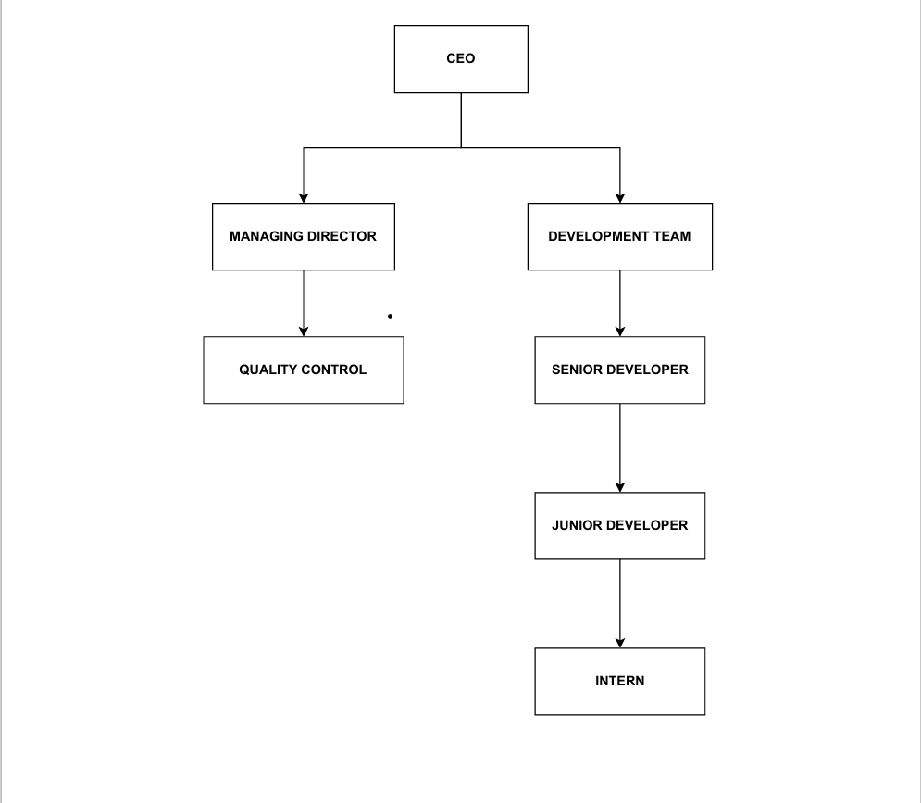

Figure 2. 2: Organization Chart

The organizational structure of Global-Tech Nepal Pvt. Ltd. is designed to ensure efficient management and seamless workflow across various departments. At the top of the hierarchy is the Chief Executive Officer (CEO), who is responsible for the overall strategic direction and management of the company. The CEO oversees all operations and ensures that the company's mission and vision are effectively implemented.

Reporting directly to the CEO is the Managing Director, who plays a crucial role in executing the company's strategic plans and policies. The Managing Director oversees the various departments, ensuring that they operate smoothly and align with the company's objectives. Under the Managing Director, the organization is divided into two main teams: Quality Control and the Development Team.

The development team is further divided into roles based on experience and expertise. Leading the development team is the senior developer, who is responsible for guiding the technical direction of projects and mentoring other team members. Reporting to the senior developer are the junior developers, who handle the more routine coding tasks and support the development of projects under the guidance of the senior team members. At the entry level are the interns, who assist the junior developers and gain hands-on experience in software development. Interns are provided with mentorship and training to help them develop their skills and contribute to the team's projects.

## **2.3 Work Domain of Organization**

Global-Tech Nepal Pvt. Ltd. operates at the forefront of information technology and cloud computing services, offering a diverse range of specialized solutions. The company excels in software development, delivering tailored applications such as Organization Management Software (OMS) and Enterprise Resource Planning (ERP) systems designed to meet specific client needs. Renowned for its robust cloud computing services, Global-Tech Nepal ensures secure, scalable solutions with strong disaster recovery capabilities, encompassing Infrastructure as a Service (IaaS), Platform as a Service (PaaS), and Software as a Service (SaaS) offerings.

In addition to its technological expertise, the company provides professional accounting training and consulting services, empowering businesses to optimize financial operations effectively. Their comprehensive web solutions portfolio includes portal development, web application development, content management systems (CMS), API integration, and e-commerce solutions, catering to varied client requirements.

**Services Provided by Global-Tech Nepal Pvt. Ltd.:**

* Software Development
* Cloud Computing (IaaS, PaaS, SaaS)
* Professional Accounting Training and Consulting
* Web Solutions: Portal Development, Web Applications, CMS
* API Integration and E-Commerce Solutions

Through its commitment to innovation, quality, and client satisfaction, Global-Tech Nepal Pvt. Ltd. continues to be a significant player in the IT industry, driving technological advancements and delivering cutting-edge solutions to its clients.

## **2.4 Description of Intern Department/Unit**

The intern department at Global-Tech Nepal Pvt. Ltd. operates within the Development Team, a vital component responsible for crafting the company's software and web solutions. Led by the Senior Developer, this unit focuses on the design, development, and maintenance of various software products and services, ensuring they meet the company's quality and performance standards. Interns within this department collaborate closely with junior developers, engaging in diverse tasks spanning frontend and backend development, including coding, debugging, and testing software applications, as well as assisting in database management tasks such as SQL querying.

Each intern is assigned specific tasks and projects within the development team, accompanied by clear deadlines, fostering a culture of accountability and time management. This structured approach not only cultivates interns' technical skills but also instills professional discipline, preparing them for the demands of the industry. Through hands-on learning and mentorship, interns gain a holistic understanding of the software development lifecycle, from requirements analysis to deployment, while experiencing the collaborative dynamics inherent in professional software development environments.

## **2.5 Literature Review / Related Study**

**Prameela, K. M., Rehka, D. S., Kusuma, M., Subramanyam, N. B., & Kumar, M. N. (2024). Tourist guide system using ASP.NET. Sri Vasavi Engineering College.**

This paper introduces a tourist guide system developed using ASP.NET, which focuses on enhancing user experience by offering a personalized travel and tour management system. The platform provides comprehensive information on transportation, tourist attractions, and accommodations, enabling travelers to make informed decisions. This study highlights the capability of ASP.NET to create user-centric web applications with robust functionalities. It demonstrates how ASP.NET can be utilized to deliver customized solutions, making it relevant to projects involving dynamic web applications and user-focused designs.

**Serbout, S., & Pautasso, C. (2024). How are web APIs versioned in practice? A large-scale empirical study. Software Institute (USI).**

This study explores API versioning practices, a crucial aspect of maintaining compatibility and managing API evolution. By analyzing a large dataset of API specifications, the study examines various versioning strategies used by developers. This paper is highly relevant to projects on Web API development for data interaction, providing insights into best practices for API versioning and the importance of maintaining API compatibility and stability. The study's findings offer valuable guidance for developing and maintaining robust APIs in ASP.NET.

**Rishikesh, P., Velavalapalli, S. V., Unnamatala, S., Ganesh, G. R. S. S. S., & Prasad, V. B. D. (2022). Pro-Health Navigating System in healthcare organizations. Sri Vasavi Engineering College.**

This paper discusses the Pro-Health Navigating System, which improves efficiency and patient care in healthcare organizations through effective data management and automated processes. The system handles patient registration, detail storage, and computerized billing, showcasing the significance of robust database management and system integration. The paper emphasizes the importance of efficient CRUD operations and database management using SQL Server Management Studio (SSMS), highlighting best practices for system implementation in healthcare contexts.

# **CHAPTER 3-INTERNSHIP ACTIVITIES**

## **3.1 Roles and Responsibility**

In the intern department at Global-Tech Nepal Pvt. Ltd., each member, including interns, is assigned specific roles and responsibilities to contribute effectively to the team's objectives.

**Intern Responsibilities:**

* Assist in frontend and backend development tasks, including coding, debugging, and testing software applications.
* Collaborate with junior developers and other team members to complete assigned projects within specified timelines.
* Participate in requirements analysis, design discussions, and code reviews under the guidance of senior team members.
* Contribute to database management tasks, such as writing SQL queries and ensuring data integrity within applications.
* Communicate effectively with team members to provide progress updates, seek assistance when needed, and actively participate in team meetings and discussions.

## **3.2 Weekly Log**

Table 3.1: Details of Weekly Log

|  |  |  |
| --- | --- | --- |
| **Week** | **Tasks** | **Outcome** |
| Week 1 | - Create a login page. - Add CSS and JavaScript for styling and client-side validation.  - Render page as a view (C# ASP.NET MVC).  - Validate user (server-side). | Successfully created and styled a login page, integrated client-side and server-side validation, and rendered the page as a view. |
| Week 2 | - Design an ER diagram, a class diagram, and an activity diagram for a Company Registration System. | Successfully Design an ER diagram, a class diagram, and an activity diagram for a company registration system. |
| Week 3 | - Create a table and stored procedure for create, update, and delete in SQL Server Management Studio.  - Perform CRUD operations using ASP.NET MVC. | Established a database table and stored procedures, and implemented CRUD operations via ASP.NET MVC. |
| Week 4 | - Select a list of companies from the database and display in the view based on user-entered date. | Successfully retrieved and displayed a list of companies based on the user-provided date. |
| Week 5 | - Select a list of companies from the database and display in the view based on user-entered company name.  - Create a dropdown for company entry and report. | Successfully retrieved and displayed a list of companies based on the user-provided company name and implemented a dropdown for company entry and reporting. |
| Week 6 | - Create login and registration pages, authenticate and authorize users.  - Create a payment model, controller, and view; update the installation and renewal dates upon payment. | Successfully created and validated login and registration pages, and implemented payment processing with corresponding updates to installation and renewal dates. |
| Week 7 | - Create a Model, View, and Controller for a loan category (given field names).  - Perform CRUD operations.  - Authenticate and authorize users. | Successfully created a loan category module with CRUD operations and user authentication and authorization. |
| Week 8 | - Design an ER diagram, a class diagram, and an activity diagram for a Loan Management System. | Successfully Design an ER diagram, a class diagram, and an activity diagram for a Loan Management System. |
| Week 9 | - Create master tables for Overdraft and Working Capital  - Create a loan category table and link it with master tables | Successfully created master tables for Overdraft and Working Capital, and linked the loan category table with both master tables. |
| Week 10 | - Create models for each table (Overdraft, Working Capital, Loan Category)  - Create views for each table (Overdraft, Working Capital, Loan Category)  - Create controllers for each table (Overdraft, Working Capital, Loan Category) | Models, views, and controllers for Overdraft, Working Capital, and Loan Category tables were successfully created. |
| Week 11 | - Perform CRUD operations for Overdraft, Working Capital, and Loan Category tables.  - Create history tables for each operation (Overdraft, Working Capital, Loan Category)  - Maintain operation history by logging CRUD actions into the corresponding history tables | CRUD operations for Overdraft, Working Capital, and Loan Category tables were successfully implemented and tested, and history tables for logging each operation were successfully created. |
| Week 12 | - Create a Web API for stock and comments to show relationships.  - Use Web API with ASP.NET Core following design principles (Repository pattern with DTO). | Successfully created a Web API demonstrating stock and comment relationships and integrated it with ASP.NET Core using the repository pattern and DTO. |

## **3.3 Description of the Projects Involved During Internship**

During the internship at Global-Tech Nepal Pvt. Ltd., the intern was involved in various tasks and projects aimed at developing skills in web development, database management, and software development using ASP.NET MVC. Although not assigned to work on specific "projects" per se, the intern engaged in a series of tasks that collectively contributed to their learning experience and skill development.

### **3.3.1 System Analysis**

System analysis, as used in software development, is the act of examining, comprehending, and recording the specifications, elements, and functionalities of a system. It entails disassembling a complicated system into smaller parts, analyzing the interactions between these parts, and determining the requirements that must be met for the system to achieve its goals.

#### **3.3.1.1 Use Case Diagram**

1. **Company Registration System**

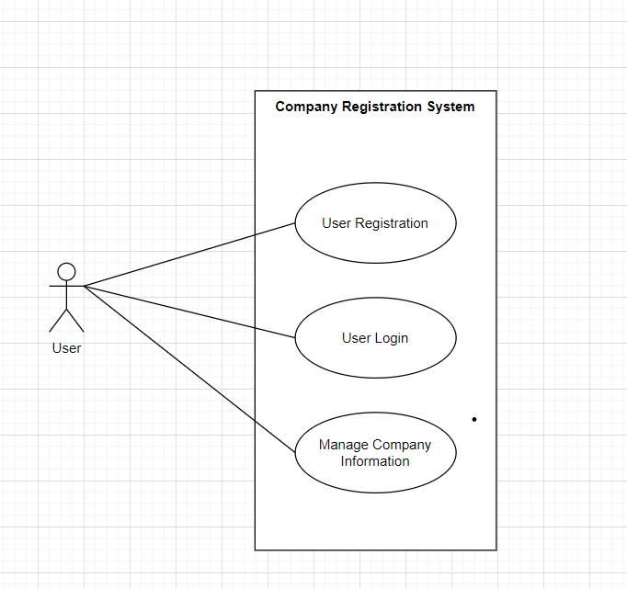

Figure 3. 1: Use Case Diagram of Company Registration System

**Use Case Description**

Table 3. 2: Use Case for Registration

|  |  |
| --- | --- |
| **Use Case Identifier** | **UC-01** |
| **Primary Actor** | User |
| **Secondary Actor** | None |
| **Description** | User registers a new account. |
| **Pre-Condition** | User is on the registration page. |
| **Success Scenario** | User submits the form with valid data and receives a confirmation message. |
| **Failure Scenario** | User submits the form with invalid data and receives an error message. |

Table 3. 3: Use Case for Login

|  |  |
| --- | --- |
| **Use Case Identifier** | **UC-02** |
| **Primary Actor** | User |
| **Secondary Actor** | None |
| **Description** | User logs into the system. |
| **Pre-Condition** | User has a registered account. |
| **Success Scenario** | User submits valid credentials and accesses the system. |
| **Failure Scenario** | User submits invalid credentials and receives an error message. |

Table 3. 4: Use Case for Manage Company Information

|  |  |
| --- | --- |
| **Use Case Identifier** | **UC-03** |
| **Primary Actor** | Admin |
| **Secondary Actor** | None |
| **Description** | Admin creates, reads, updates, or deletes loan categories. |
| **Pre-Condition** | Admin is logged in. |
| **Success Scenario** | Admin successfully performs CRUD operations on loan categories. |
| **Failure Scenario** | Admin encounters an error during CRUD operations. |

1. **Loan Management System**

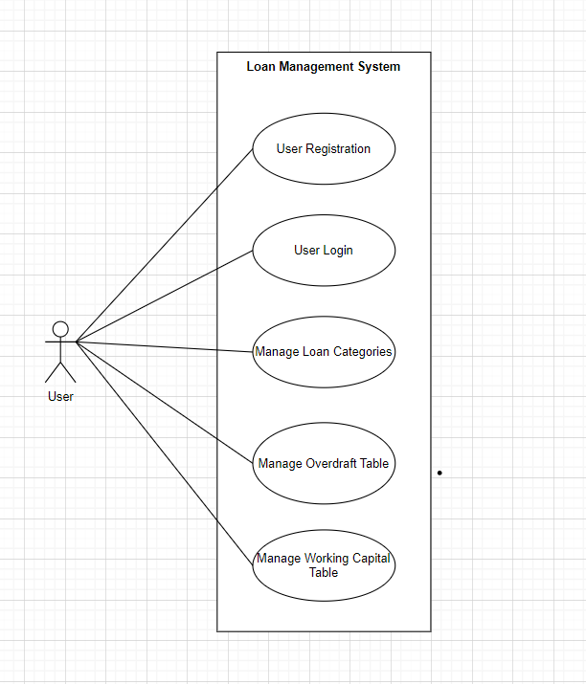

Figure 3. 2: Use Case Diagram of Loan Management System

**Use Case Description**

Table 3. 5: Use Case for User Registration

|  |  |
| --- | --- |
| **Use Case Identifier** | **UC-01** |
| **Primary Actor** | User |
| **Secondary Actor** | None |
| **Description** | User registers a new account. |
| **Pre-Condition** | User is on the registration page. |
| **Success Scenario** | User submits the form with valid data and receives a confirmation message. |
| **Failure Scenario** | User submits the form with invalid data and receives an error message. |

Table 3. 6: Use Case for User Login

|  |  |
| --- | --- |
| **Use Case Identifier** | **UC-02** |
| **Primary Actor** | User |
| **Secondary Actor** | None |
| **Description** | User logs into the system. |
| **Pre-Condition** | User has a registered account. |
| **Success Scenario** | User submits valid credentials and accesses the system. |
| **Failure Scenario** | User submits invalid credentials and receives an error message. |

Table 3. 7: Use Case for Manage Loan Categories

|  |  |
| --- | --- |
| **Use Case Identifier** | **UC-03** |
| **Primary Actor** | Admin |
| **Secondary Actor** | None |
| **Description** | Admin creates, reads, updates, or deletes Loan Categories. |
| **Pre-Condition** | Admin is logged in. |
| **Success Scenario** | Admin successfully performs CRUD operations on Loan Categories. |
| **Failure Scenario** | Admin encounters an error during CRUD operations. |

Table 3. 8: Use Case for Manage Overdraft Table

|  |  |
| --- | --- |
| **Use Case Identifier** | **UC-04** |
| **Primary Actor** | Admin |
| **Secondary Actor** | None |
| **Description** | Admin creates, reads, updates, or deletes overdraft records. |
| **Pre-Condition** | Admin is logged in. |
| **Success Scenario** | Admin successfully performs CRUD operations on overdraft records. |
| **Failure Scenario** | Admin encounters an error during CRUD operations. |

Table 3. 9: Use Case for Manage Working Capital Table

|  |  |
| --- | --- |
| **Use Case Identifier** | **UC-05** |
| **Primary Actor** | Admin |
| **Secondary Actor** | None |
| **Description** | Admin creates, reads, updates, or deletes working capital records. |
| **Pre-Condition** | Admin is logged in. |
| **Success Scenario** | Admin successfully performs CRUD operations on working capital records. |
| **Failure Scenario** | Admin encounters an error during CRUD operations. |

### **3.3.2 System Design**

The design of the system unfolds as a crucial stage where an object-oriented approach is employed to intricately weave analysis insights into a meticulously structured system architecture. This process entails the crafting of detailed class diagrams, the refinement of dynamic modeling concepts into clear state and sequence diagrams, and the seamless transition of process modeling into intuitive activity diagrams. The overarching objective is to architect a robust and scalable system, ensuring each design element resonates seamlessly with the project's requirements. This phase serves as a foundational stepping stone, setting the emotional groundwork for subsequent implementation and testing phases.

#### **3.3.2.1 MVC Methodology in ASP.NET**

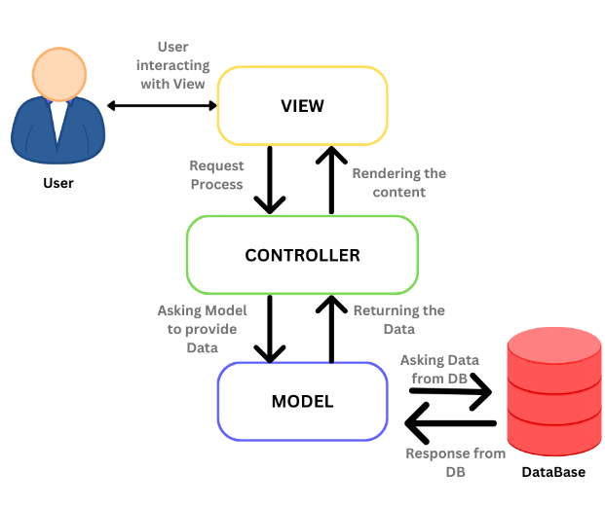

Figure 3. 3: MVC

The Model-View-Controller (MVC) architecture, central to ASP.NET MVC framework, divides web applications into three interconnected components to improve code organization and maintainability. The Model represents the application's data structure and business logic, handling data access, validations, and business rules. Views, on the other hand, manage the presentation layer, rendering UI elements using Razor syntax to generate dynamic HTML based on data from the Model. Controllers act as intermediaries between Models and Views, handling user input, processing requests, and deciding which View to display. This separation of concerns ensures that business logic (Model), presentation logic (View), and user interaction (Controller) remain distinct, facilitating easier code maintenance, testing, and scalability. ASP.NET MVC provides tools like routing, model binding, and action filters to streamline development while adhering to MVC principles, making it a robust framework for building modern web applications.

#### **3.3.2.2 ER Diagram**

1. **Company Registration System**

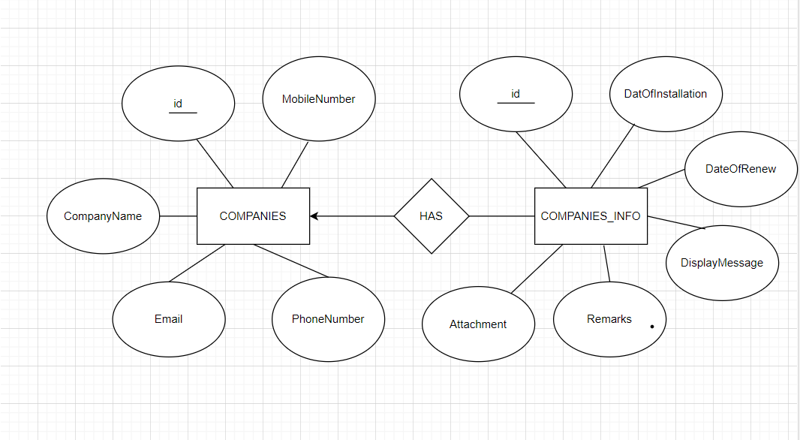

Figure 3. 4: ER Diagram of Company Registration System

1. **Loan Management System**

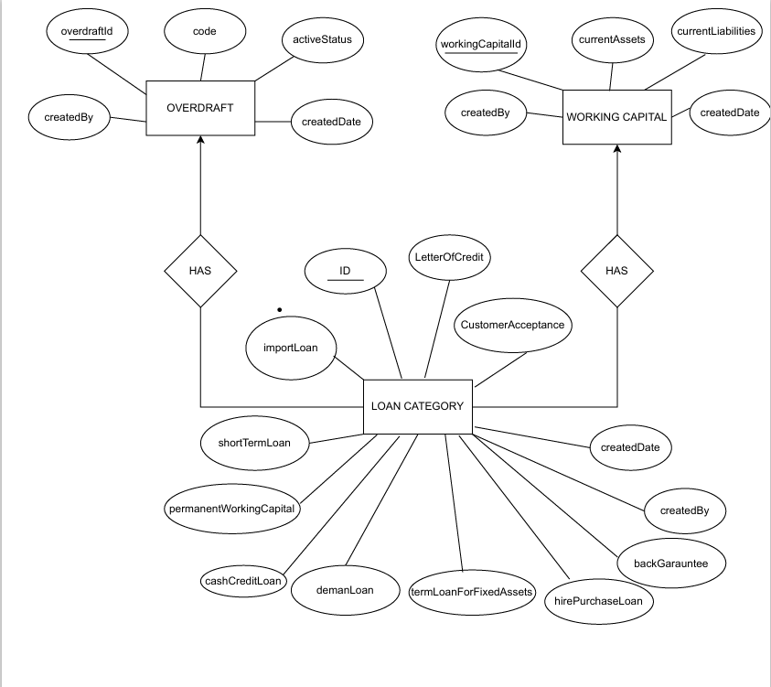

Figure 3. 5: ER Diagram of Loan Management System

#### **3.3.2.3 Class Diagram**

1. **Company Registration System**

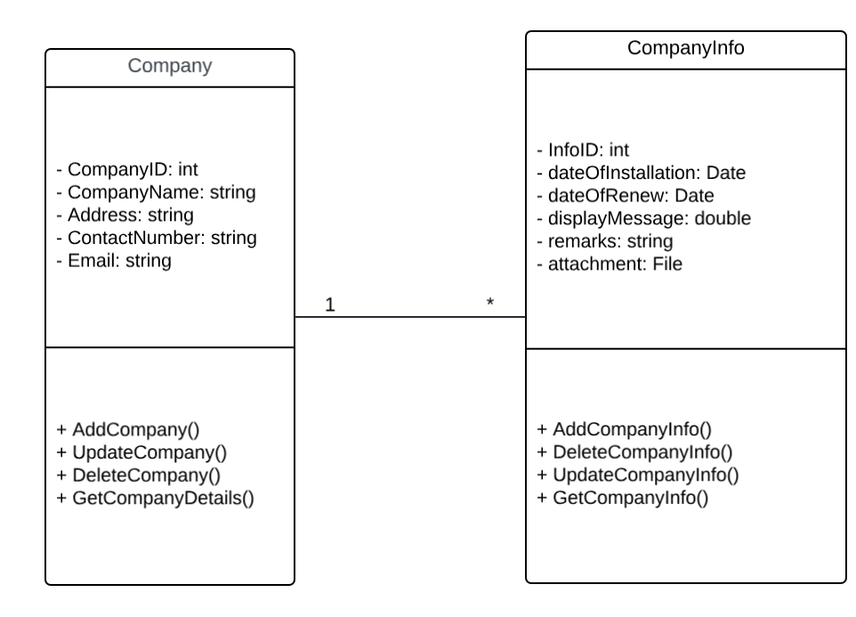

Figure 3. 6: Class Diagram of Company Registration System

1. **Loan Management System**

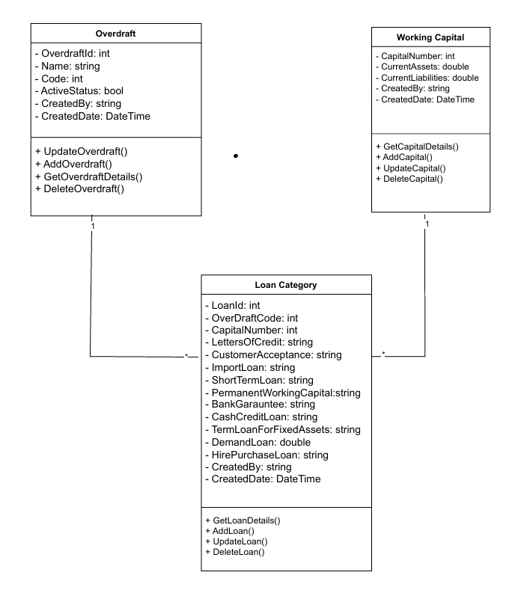

Figure 3. 7: Class Diagram of Loan Management System

#### **3.3.2.4 Activity Diagram**

1. **Company Registration System**

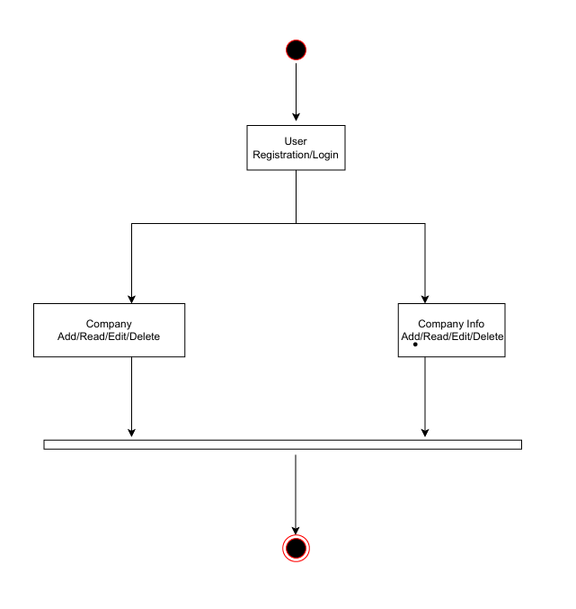

Figure 3. 8: Activity Diagram of Company Registration System

1. **Loan Management System**

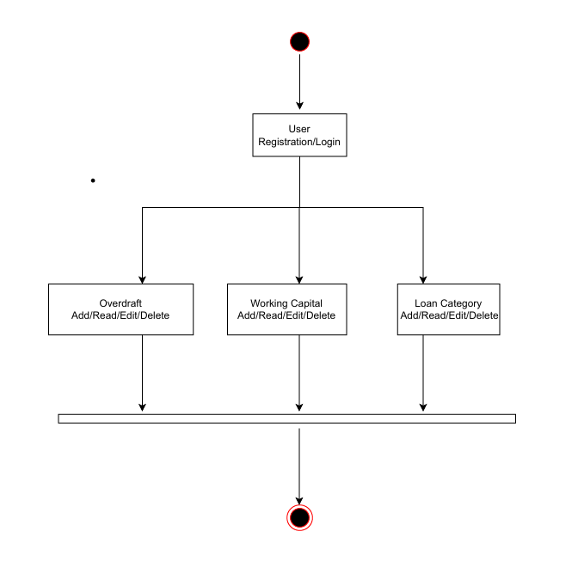

Figure 3. 9: Activity Diagram of Loan Management System

### **3.3.3 Tasks Completed**

1. **Company Registration System Development:**

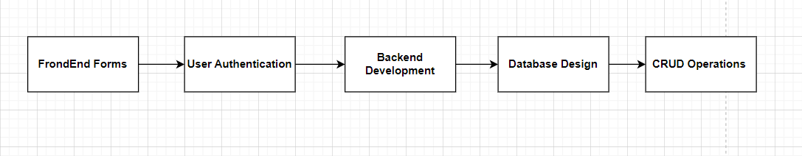

Figure 3. 10: Company Registration System

* Created login and registration pages for user authentication.
* Implemented frontend forms using CSS and JavaScript to improve styling and enable client-side validation.
* Utilized C# ASP.NET MVC to render pages as views and integrated server-side validation mechanisms.
* Designed a database system comprising two interconnected tables: company and company_info.
* Implemented database tables and stored procedures in SQL Server Management Studio to support CRUD operations.
* Integrated ASP.NET MVC to ensure efficient execution of CRUD operations and seamless database interactions.
* Employed ADO.NET to enhance data access capabilities, improving the application's interaction with the database.

1. **Loan Management System Development:**

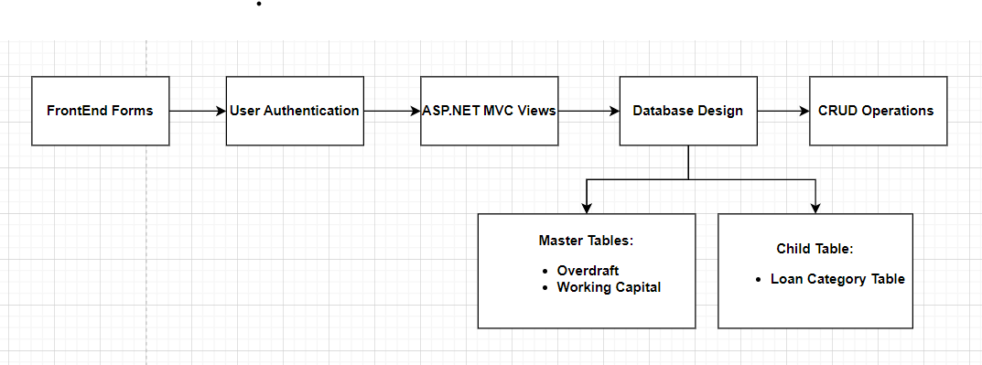

Figure 3. 11: Loan Management System

* Designed and implemented login and registration pages for user authentication and system access control.
* Utilized C# ASP.NET MVC to render pages as views and integrated server-side validation mechanisms.
* The system comprises two master tables: Overdraft and Working Capital, along with one child table, Loan Category Table.
* Established a parent-to-child relationship between the tables, enabling one-to-many associations.
* Implemented CRUD operations for the Loan Category Table, restricted to active Overdraft models.
* Designed and implemented database tables and stored procedures in SQL Server Management Studio to support CRUD operations.
* Integrated ASP.NET MVC for efficient execution of CRUD operations, ensuring seamless database interactions.
* Leveraged ADO.NET to enhance data access capabilities, optimizing the application's interaction with the database.

1. **Web API Development for Data Interaction:**
   * Created a Web API to demonstrate relationships between stock and comments.
   * Developed the API using ASP.NET Core, following best practices such as the repository pattern with DTO.
   * Integrated the Web API into the web application, improving data interaction and adhering to design principles.

Table 3. 10: Internship Duration

|  |  |
| --- | --- |
| Time Period | March 11th, 2024 – June 3rd, 2024 |
| Days per week | 6 days |
| Hours per day | 7 Hours (11:00 am – 6:00 pm) |
| Holiday | Saturday |
| Internship Period | 2 months and 24 days |
| Mentor | Anish Koju Shrestha |

**Working Environment**

**Frontend:** HTML, CSS, JavaScript, Bootstrap5

**Backend:** C# (ASP.NET MVC)

**Communication**: IP Messenger

## **3.4 Tasks / Activities Performed**

During the internship at Global-Tech Nepal Pvt. Ltd., a variety of technical tasks and activities were undertaken, contributing to skill development and practical knowledge in software development. Below are the key tasks and activities performed:

1. **Frontend Development:**
   * Implemented user interface components using HTML, CSS, JavaScript, and Bootstrap5.
   * Ensured responsiveness and compatibility across different devices and browsers.
2. **Backend Development:**
   * Developed server-side logic and functionality using C# with ASP.NET MVC framework.
   * Integrated frontend and backend components to create dynamic web applications.
3. **Database Management:**
   * Designed and implemented database schemas using SQL Server Management Studio.
   * Implemented CRUD operations to interact with the database and manage data effectively.
4. **User Authentication and Authorization:**
   * Developed user authentication and authorization systems to secure web applications.
   * Implemented login and registration functionalities with appropriate validation and error handling.
5. **Web API Development:**
   * Created RESTful APIs using ASP.NET Core to enable data interaction between frontend and backend components.
   * Implemented endpoints for data retrieval, manipulation, and validation.
6. **Testing and Debugging:**
   * Conducted unit testing and debugging of code to ensure functionality and performance.
   * Identified and resolved software defects and issues in a timely manner.
7. **Collaboration and Communication:**
   * Collaborated with team members to discuss project requirements, tasks, and timelines.
   * Communicated effectively through tools such as IP Messenger to coordinate activities and share updates.
8. **Continuous Learning and Improvement:**
   * Engaged in self-learning and exploration of new technologies and best practices in software development.
   * Actively participated in training sessions, workshops, and knowledge sharing sessions within the organization.

Overall, the tasks and activities performed during the internship provided valuable hands-on experience and contributed to the development of technical skills, problem-solving abilities, and collaboration skills in a professional software development environment.

Table 3. 11: Tools Used

|  |  |
| --- | --- |
| **Category** | **Tools** |
| Frontend Development | HTML, CSS, JavaScript, Bootstrap5 |
| Backend Development | C# (ASP.NET MVC), ASP.NET Core |
| Database Management | SQL Server Management Studio |
| Web Browser | Microsoft Edge, Chrome |
| Version Control | Git, GitHub |
| Communication | IP Messenger |
| Integrated Development Environment (IDE) | Visual Studio |

# **CHAPTER 4-CONCLUSION AND LEARNING OUTCOME**

## **4.1 Conclusion**

The internship at Global-Tech Nepal Pvt. Ltd. offered a rich learning experience in software development using ASP.NET MVC, enhancing practical skills through projects like the Company Registration System, Payment and Loan Management System, and a Web API for data interaction. The intern developed secure user authentication and authorization, managed databases with SQL Server and ADO.NET, and improved user experience with dynamic data displays and reporting. Despite challenges with direct SQL queries and resource constraints, the internship provided invaluable insights into full-stack development, fostering a strong foundation for future professional growth in the IT industry

## **4.2 Learning Outcome**

During the internship at Global-Tech Nepal Pvt. Ltd., the intern achieved significant learning outcomes that will enhance their professional growth in software development:

* Proficiency in frontend technologies: HTML, CSS, JavaScript, and Bootstrap5.
* Backend programming skills with C# and ASP.NET MVC.
* Database management expertise including design, CRUD operations, and SQL Server Management Studio.
* Understanding of stored procedures and their advantages in performance, security, and maintenance.
* Knowledge of software engineering practices: user authentication, authorization, and RESTful API development.
* Improved collaboration and communication skills through teamwork and use of tools like IP Messenger.
* Commitment to continuous learning and adaptability, exploring new technologies.
* Hands-on experience in projects like Company Registration System, Payment and Loan Management System, and Web API development.

# **REFERENCES**

Prameela, K. M., Rehka, D. S., Kusuma, M., Subramanyam, N. B., & Kumar, M. N. (2024). *Tourist guide system using ASP.NET*. Sri Vasavi Engineering College.

Serbout, S., & Pautasso, C. (2024). How are web APIs versioned in practice? A large-scale empirical study. *Software Institute (USI)*.

Rishikesh, P., Velavalapalli, S. V., Unnamatala, S., Ganesh, G. R. S. S. S., & Prasad, V. B. D. (2022). *Pro-Health navigating system in healthcare organizations*. Sri Vasavi Engineering College.

# **APPENDIX**

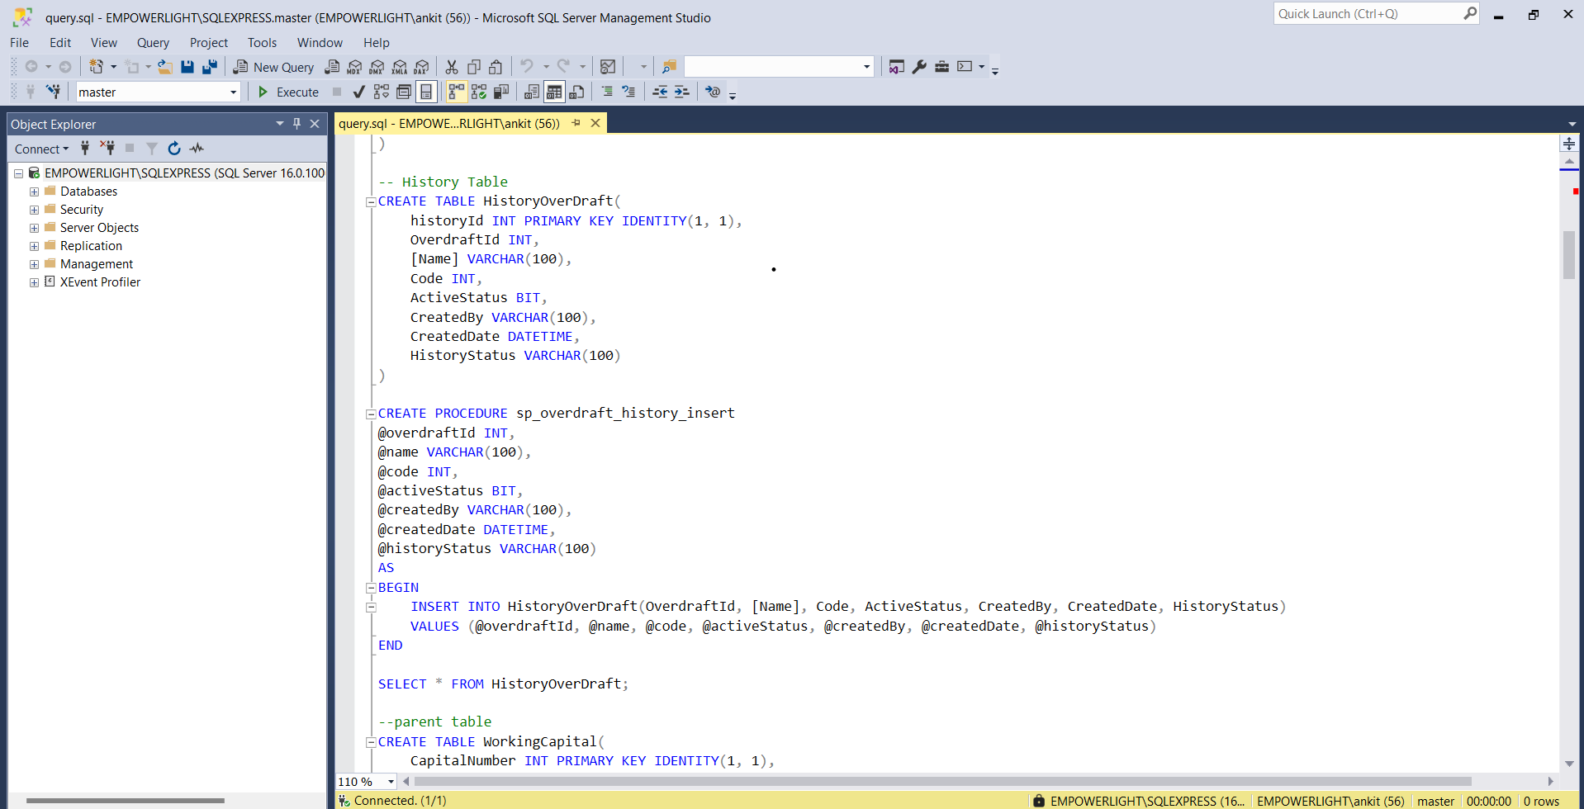

**SQL Query**

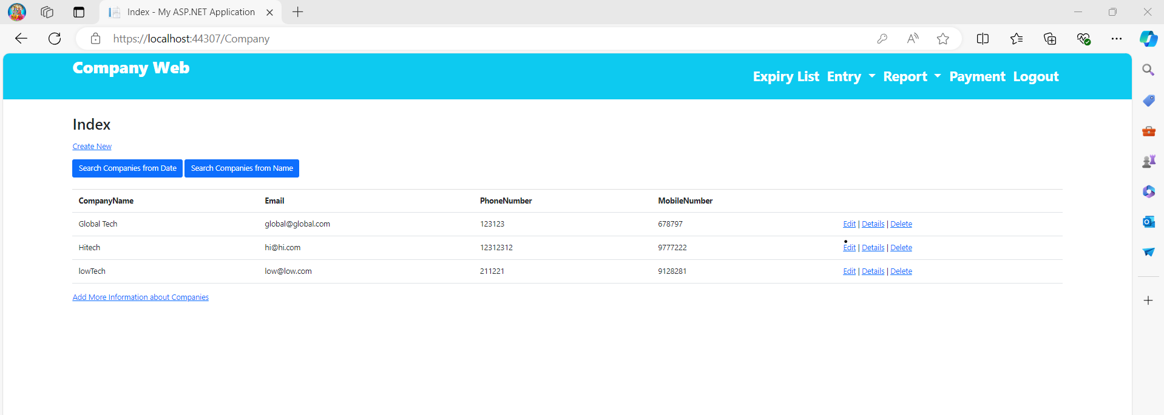

**Company List View**

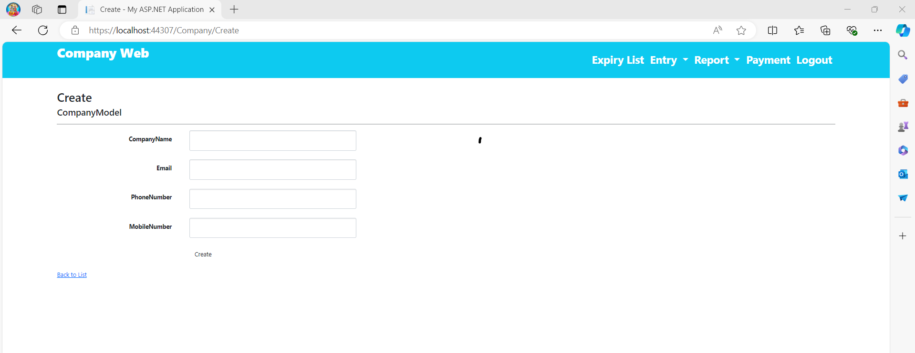

**Create Company View**

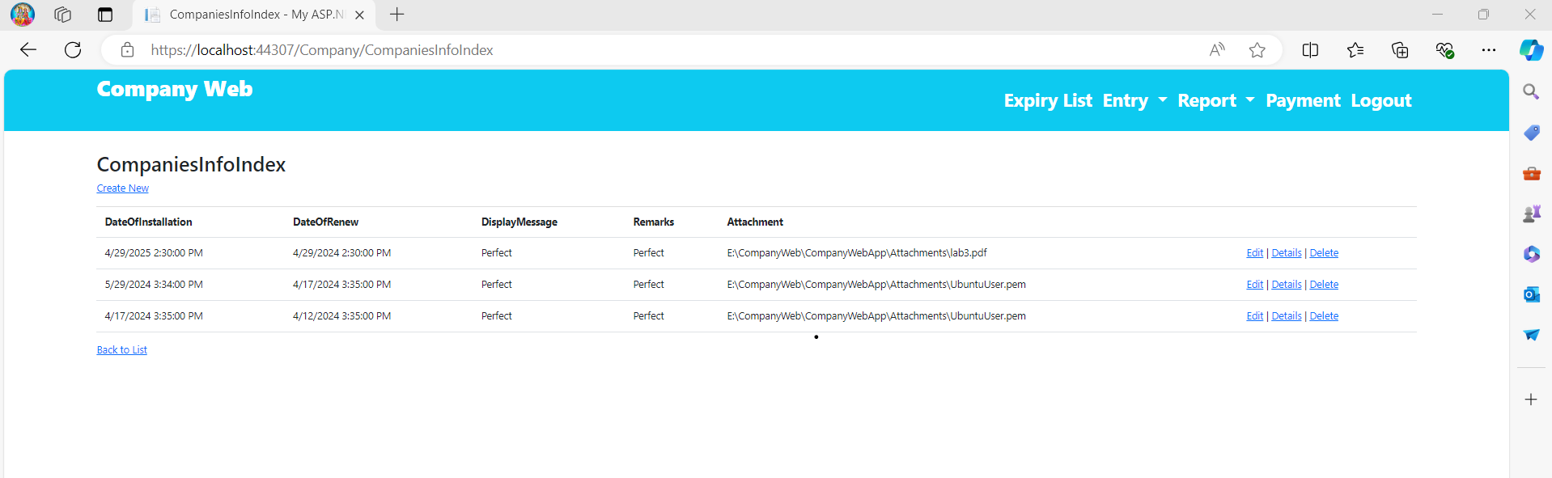

**Company Info List View**

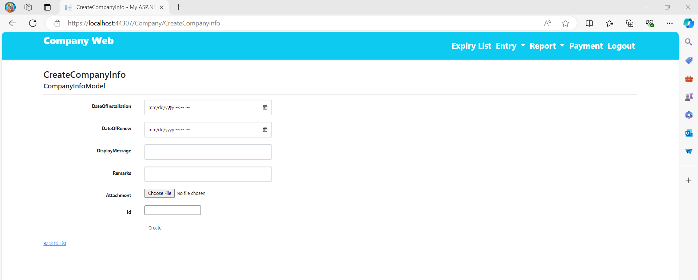

**Create Company Info View**

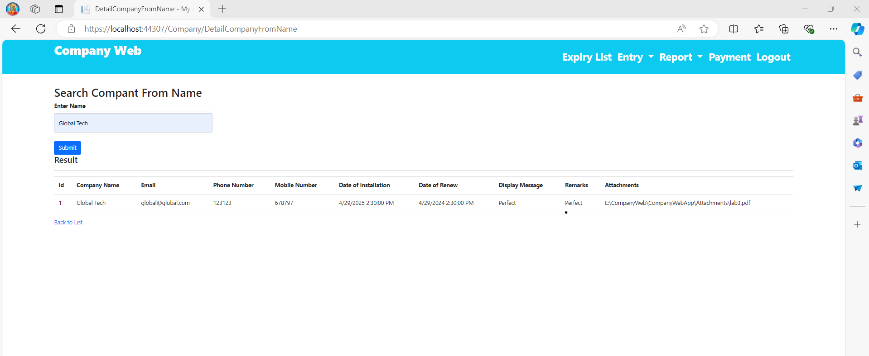

**Search Company from Name View**

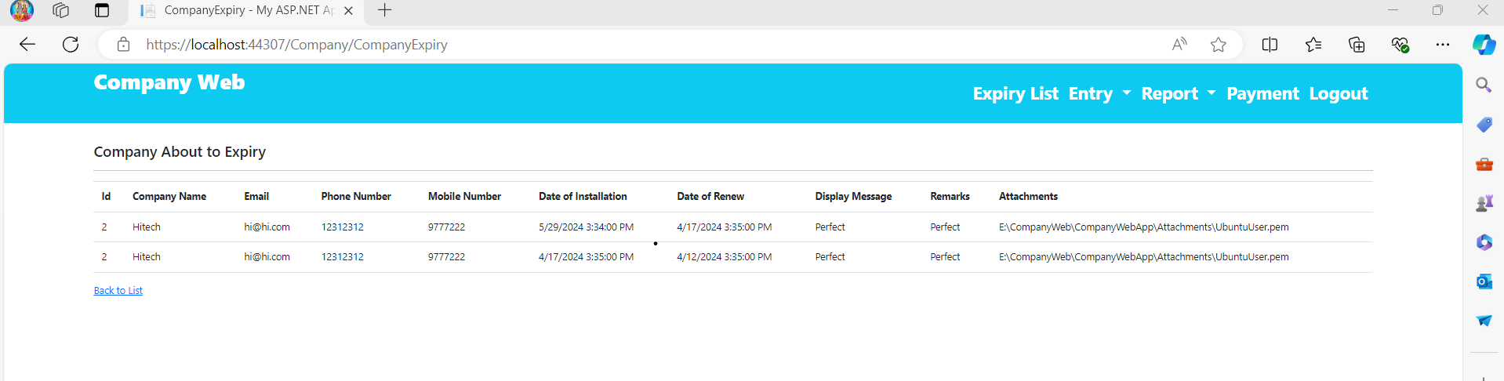

**Company Expiry List View**

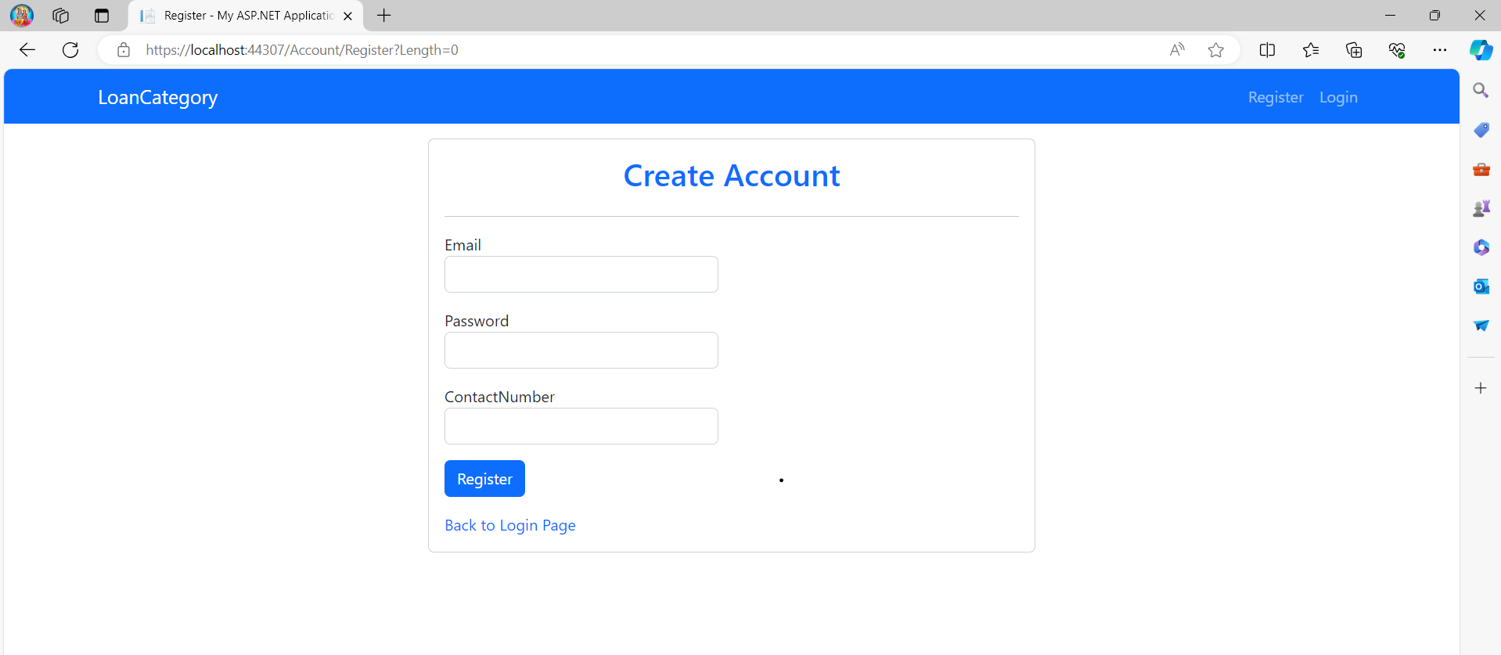

**Registration View**

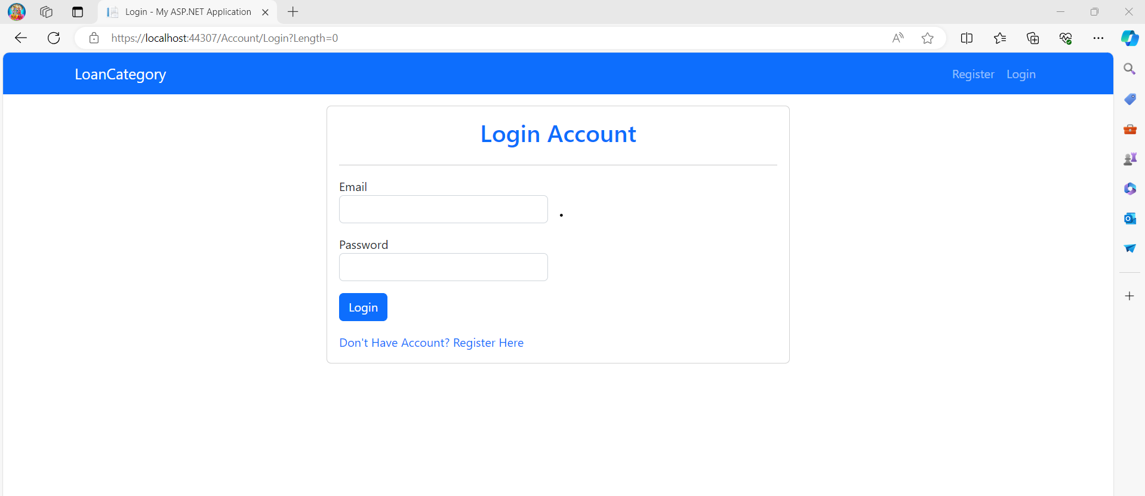

**LogIn View**

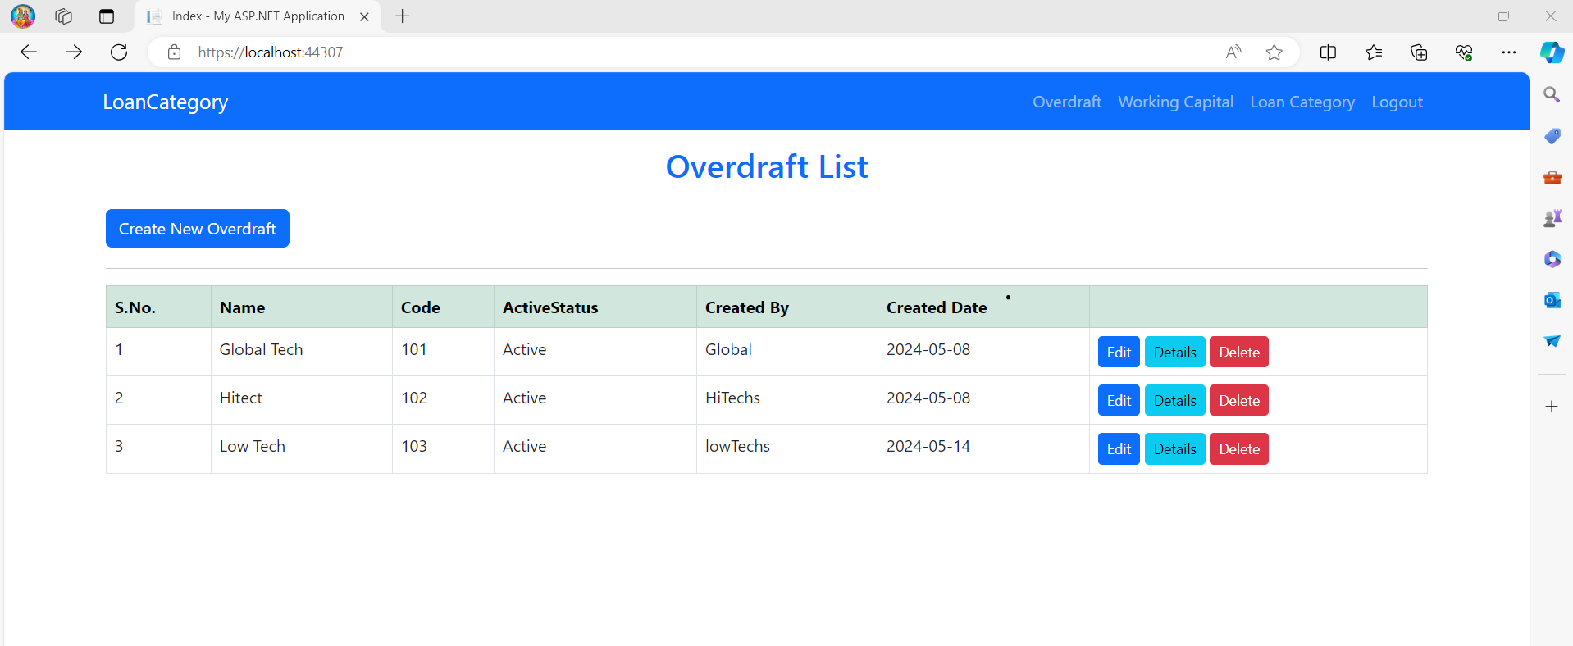

**Overdraft List View**

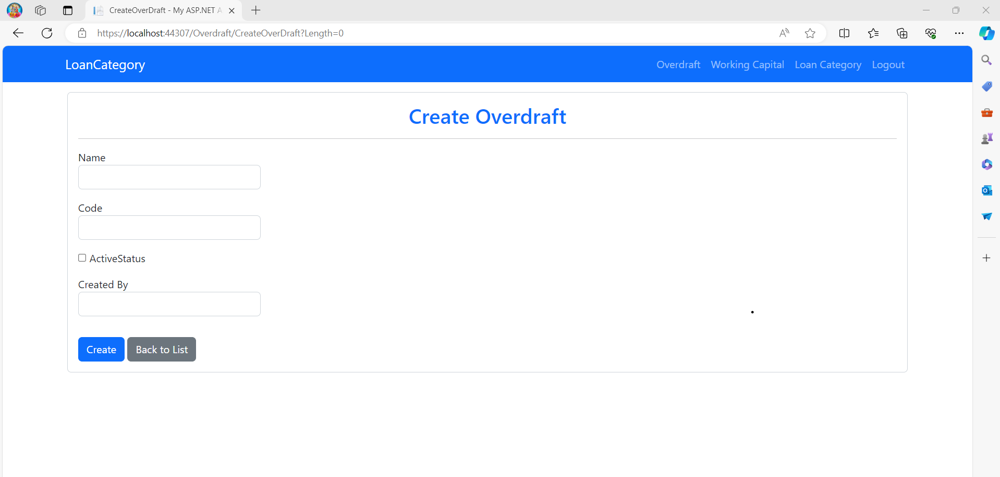

**Create Overdraft View**

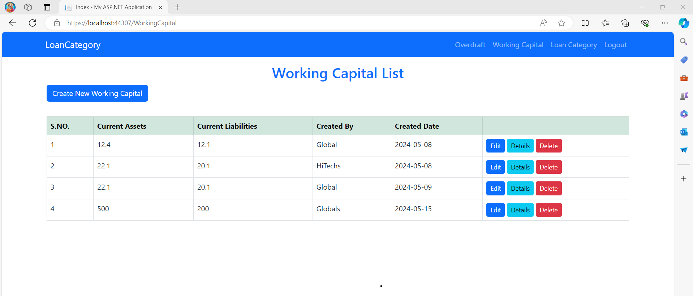

**Working Capital List View**

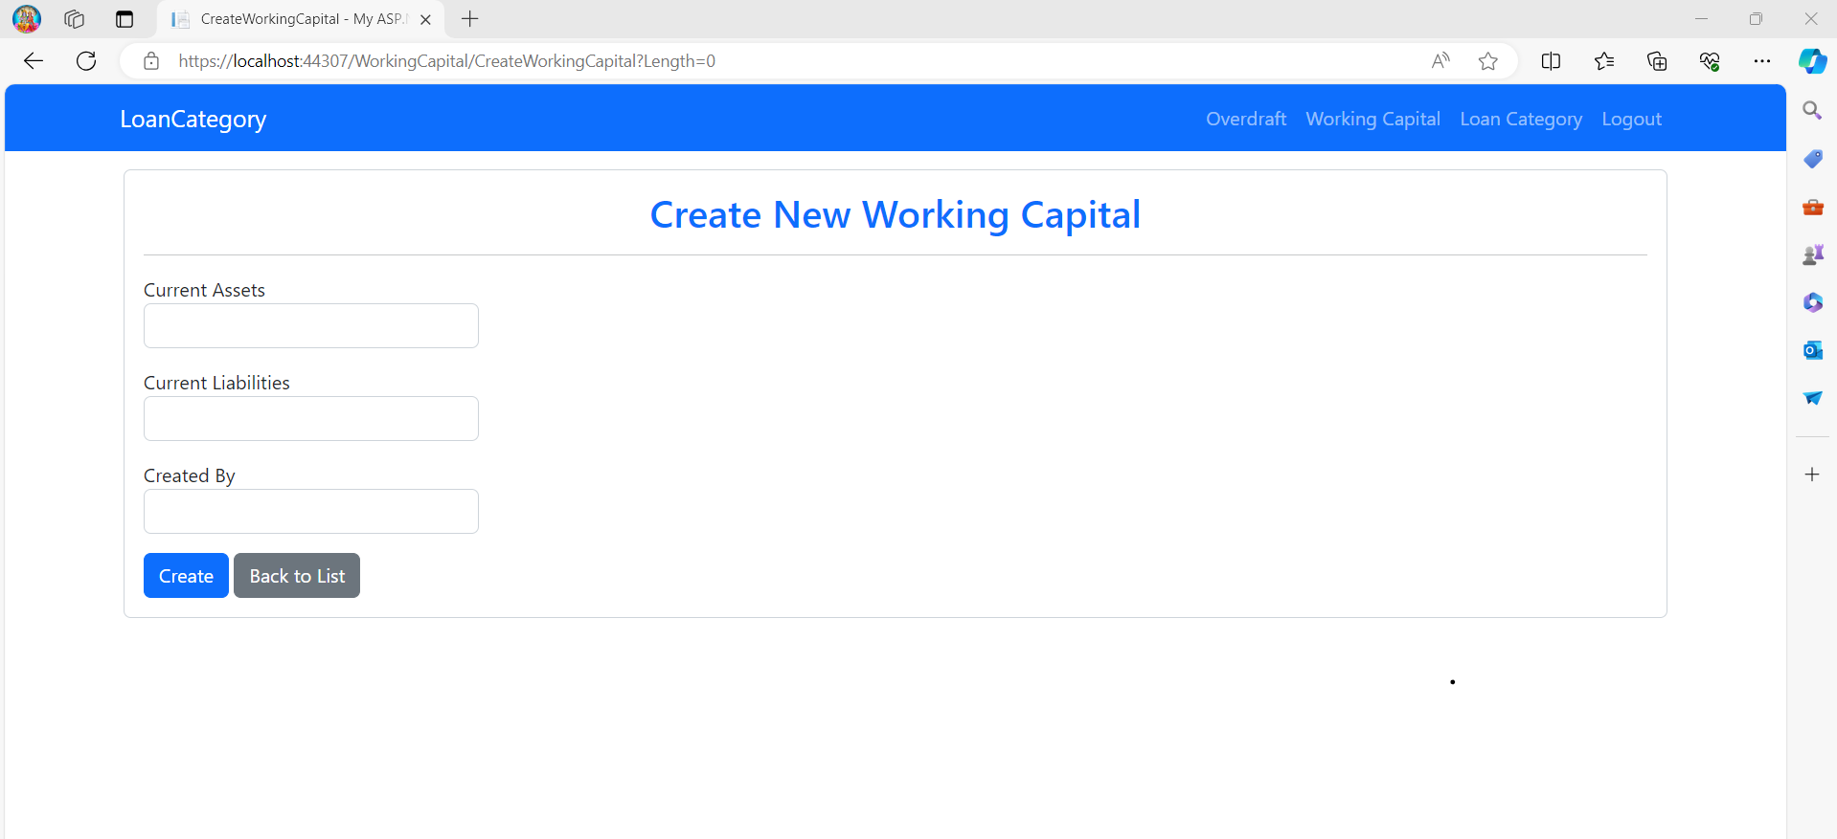

**Create Working Capital View**

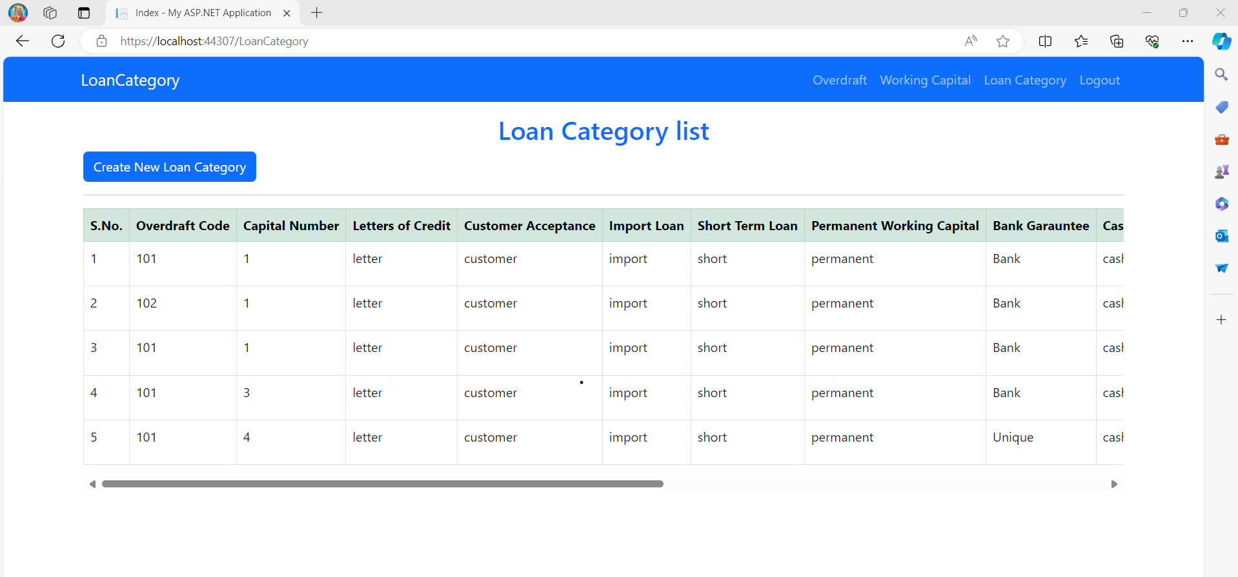

**Loan Category List View**

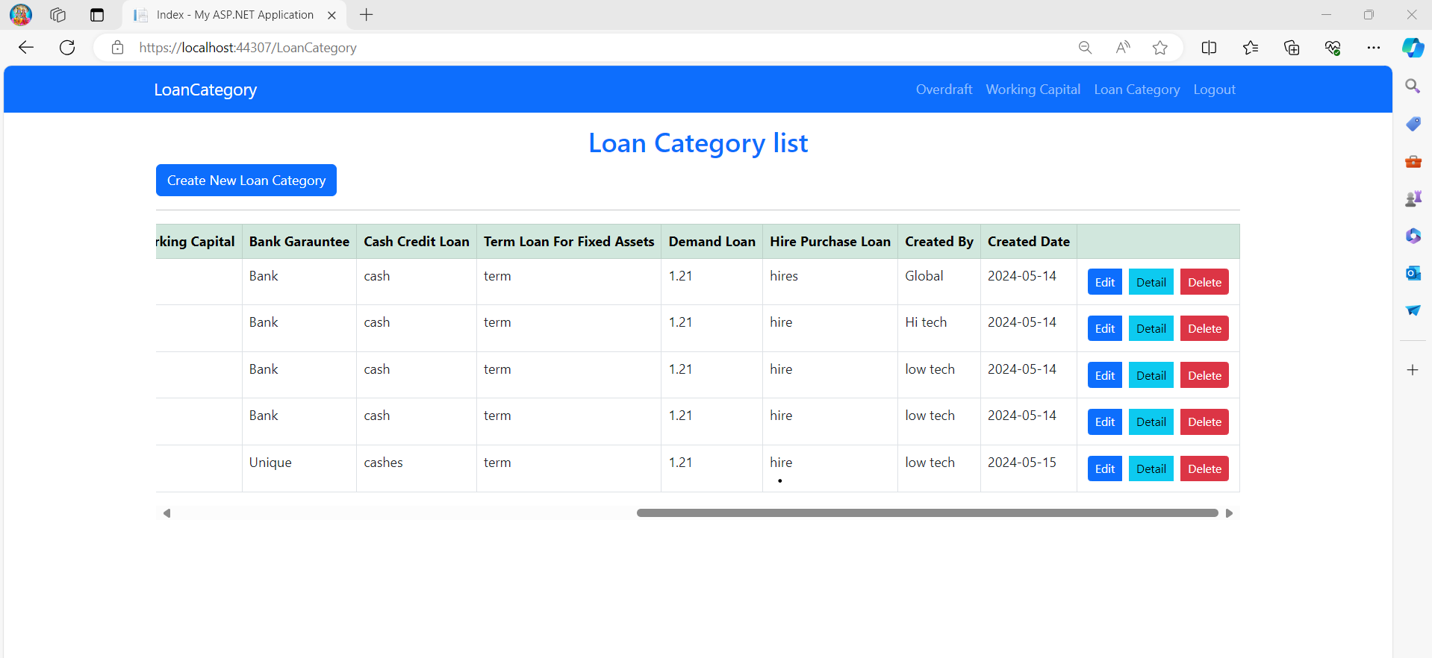

**Loan Category List View**

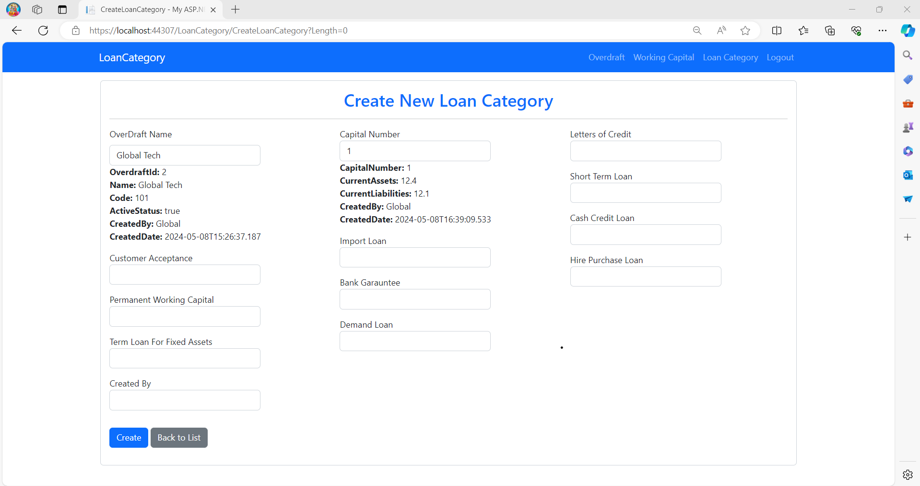

**Create Loan Category List View**

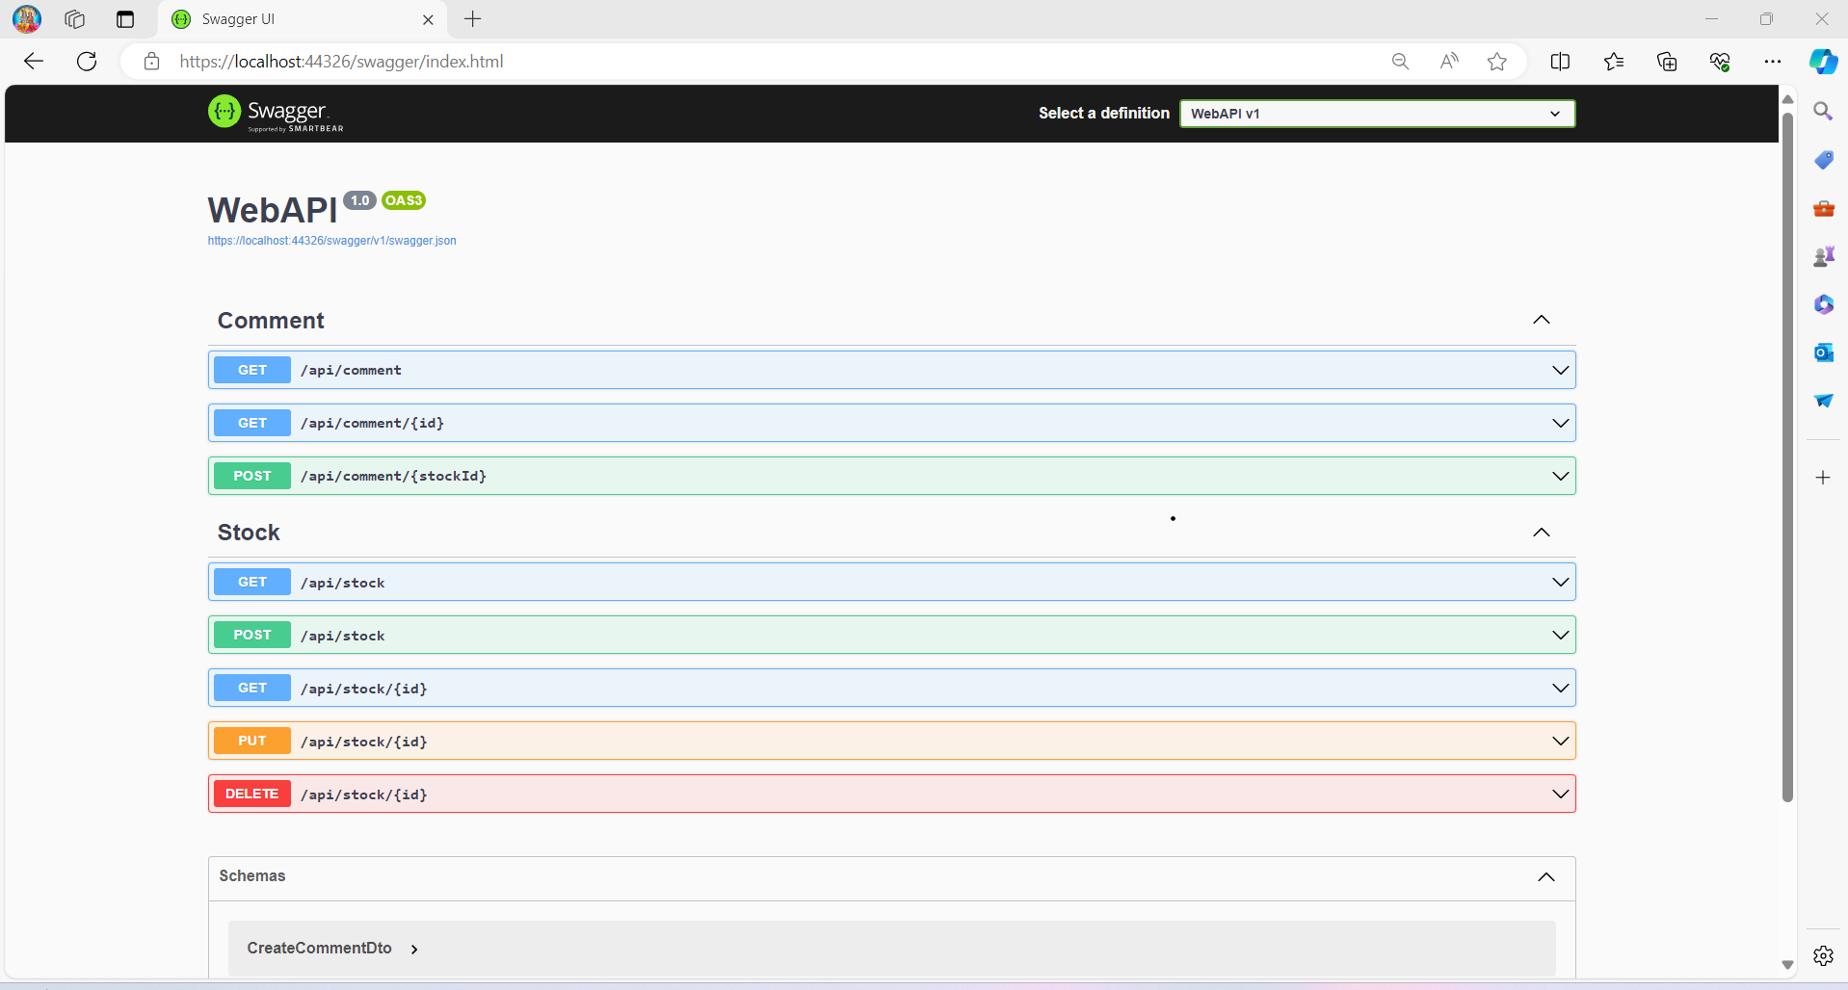

**Web API**